SIMATS ENGINEERING (SAVEETHA SCHOOL OF ENGINEERING)
Department of Computer Science and Engineering
CO3 ASSESSMENT TOOL 2 – Code Review & Repository Evaluation

Course Code: | CSA10 / CSA1063 | Course Title: | Software Engineering
CO Assessed: | CO3 | Assessment: | Assessment Tool 1 – Code Review & Repository Evaluation
Weightage: | 20% | Total Marks: | 25
CO3 Statement: | Build full-stack applications with an emphasis on containerization, version control, and collaborative development
Student Name: | S.PRATEEKSHA | Reg. No.: | 192572137
Date: | 18/8/26 | Duration: | 60 minutes

Code of Conduct
I S.PRATEEKSHA-192572137 (Name / Reg No) certify that this submission is my original work and that I have adhered to the guidelines specified for this assessment. I understand that any violation of academic integrity rules will result in disciplinary action.
Signature of the Student:S.PRATEEKSHA

Employee Performance Evaluations and Productivity Analytics System

Evaluation Criteria | Excellent (4 Marks) | Good (3 Marks) | Satisfactory (2 Marks) | Needs Improvement (1 Mark)
Problem Analysis & Repository Organization(15%) | Clearly explains the problem, solution, and repository structure with logical organization and justification. | Good explanation with minor omissions. | Basic explanation and repository \organization. | Incomplete or poorly organized repository.
Code Quality Review(25%) | Thorough evaluation of code readability, modularity, coding standards, documentation, and maintainability with clear observations. | Good code review with minor gaps. | Basic review with limited analysis. | Superficial or inaccurate code review.
Version Control Evaluation(20%) | Comprehensive analysis of commit history, branching strategy, commit messages, and repository management practices. | Good evaluation with adequate explanation. | Basic evaluation with limited evidence. | Poor or incomplete version control analysis.
Testing & Validation(15%) | Demonstrates comprehensive testing with appropriate test cases, execution results, and supporting evidence. | Good testing with minor omissions. | Basic testing with limited evidence. | Inadequate or missing testing and validation.
Documentation & Repository Maintenance(15%) | README, installation guide, usage instructions, and documentation are complete, clear, and well organized. | Documentation is mostly complete. | Basic documentation with missing details. | Poor or insufficient documentation.
Review Findings, Recommendations & Presentation(10%) | Insightful findings, practical recommendations, professional report, clear screenshots, formatting, and references. | Good recommendations and presentation. | Basic recommendations with acceptable presentation. | Weak conclusions and poor presentation.
Rubrics for Calculation

Criteria | Mark
System Requirement Analysis (30%) | /5
Selection of Software Architecture (25%) | /5
Architecture Diagram and Component Design (20%) | /5
Component Interaction and Quality Attribute Analysis (15%) | /5
Architectural Justification and Technical Presentation (10%) | /5
TOTAL | /25

Annexure A – Code Review & Repository Evaluation
Instructions to Students:
Each student has been assigned an individual problem statement. Based on the assigned problem statement, perform a Code Review and Repository Evaluation of your project. Analyze the quality of the source code, repository organization, documentation, coding practices, and overall maintainability. Provide appropriate screenshots, code snippets, diagrams, and justifications wherever applicable.

Assignment Questions
- Problem Overview
  - Explain the assigned problem statement and summarize the implemented solution.
  - Describe the project objectives and key functionalities.
1. Problem Overview
1.1 Problem Statement
Employee performance evaluation is an important activity in organizations because it helps managers understand employee productivity, work quality, and areas requiring improvement. Traditional performance evaluation methods often depend on manual records, spreadsheets, and subjective assessments. These methods can be time-consuming and make it difficult to analyze employee productivity over a period of time.
The Employee Performance Evaluations and Productivity Analytics System is developed to address this problem. The system collects employee information and performance-related data such as task completion, work quality, attendance, and deadline adherence.
The system processes these performance indicators and generates performance scores and productivity analytics. The results are presented through dashboards and reports to help managers understand employee performance and make data-driven decisions.
1.2 Implemented Solution
The proposed solution consists of a software application for managing employee information, evaluating performance, analyzing productivity, and generating reports.
The main implementation includes:
- Employee data management
- Performance data entry
- Performance score calculation
- Productivity analysis
- Dashboard visualization
- Performance report generation
- Data validation
- Testing and validation
The system workflow is:
Manager/Employee → Employee Data → Performance Metrics → Data Validation → Performance Evaluation → Productivity Analysis → Dashboard → Reports
The application is designed using a modular structure so that individual components can be maintained and improved separately. Git is used for source-code management and version control, while Docker can be used to provide a consistent application environment.
1.3 Project Objectives
The main objectives of the project are:
- To maintain employee information in a centralized system.
- To evaluate employee performance using measurable criteria.
- To calculate employee productivity scores.
- To analyze employee performance trends.
- To reduce manual effort in performance evaluation.
- To provide useful performance reports to managers.
- To support data-driven decision making.
- To maintain the source code using Git.
- To organize the project using a proper repository structure.
- To support testing and validation.
- To improve maintainability through modular coding practices.
- To support containerized deployment using Docker.
1.4 Key Functionalities
The major functionalities of the system are:
- Employee Management: Add, update, search, and maintain employee details.
- Performance Data Entry: Record task completion, work quality, attendance, and deadline-related information.
- Performance Evaluation: Calculate an overall employee performance score.
- Productivity Analysis: Analyze employee productivity using performance metrics.
- Dashboard: Display performance scores, productivity percentages, and employee statistics.
- Performance Ranking: Compare employee performance based on calculated scores.
- Report Generation: Generate employee and department-level performance reports.
- Data Validation: Validate employee and performance information before processing.
- Testing: Test the application using valid and invalid inputs.
- Version Control: Git tracks changes made during project development.
- Containerized Deployment: Docker provides a consistent environment for application execution.
- Repository Organization
  - Evaluate the repository structure, folder organization, and file naming conventions.
  - Justify how the repository layout supports maintainability and collaboration.
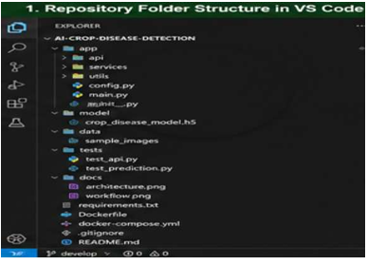

2.2 Folder Organization Evaluation
The repository is organized by separating application components according to their responsibilities.
The src folder contains the main application source code.
The models folder contains employee and performance data models.
The services folder contains important business logic such as performance evaluation and productivity analytics.
The routes folder contains application/API route definitions.
The templates folder contains the user-interface pages.
The tests folder contains testing files separately from the main application code.
The docs folder contains project documentation and architecture diagrams.
Docker-related files are placed in the root directory so that they can be easily identified during deployment.
Overall, the repository organization supports better readability, maintainability, collaboration, and scalability.
2.3 File Naming Conventions
The project uses meaningful file names that describe their purpose.
Examples include:
- app.py – Main application entry point.
- database.py – Database connection and configuration.
- employee.py – Employee information model.
- performance.py – Employee performance model.
- evaluation.py – Performance evaluation functionality.
- analytics.py – Productivity analytics functionality.
- employee_routes.py – Employee-related API routes.
- performance_routes.py – Performance-related API routes.
- test_employee.py – Employee testing.
- test_evaluation.py – Performance evaluation testing.
- test_analytics.py – Productivity analytics testing.
Meaningful naming improves code readability and helps developers quickly understand the purpose of each file.

2.4 Repository Maintainability and Collaboration
The repository structure supports maintainability because the code is divided into smaller components.
For example, a developer working on the productivity analytics functionality does not need to modify the entire application.
Similarly, employee management and performance evaluation can be developed independently.
This structure helps developers:
- Locate files easily.
- Modify individual modules.
- Test components independently.
- Reduce code duplication.
- Collaborate using Git branches.
- Maintain the project more efficiently.
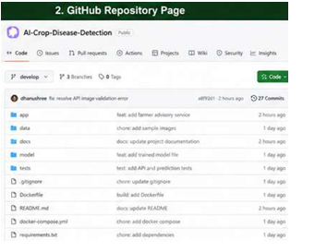

- Code Quality Review
  - Review the source code for readability, modularity, coding standards, and documentation.
  - Identify strengths and areas for improvement.

3.1 Readability Review
The source code should use meaningful function and variable names.
For example:
def calculate_productivity(completed_tasks, total_tasks):
if total_tasks == 0:
return 0

return (completed_tasks / total_tasks) * 100
The function name calculate_productivity clearly explains its purpose.
Similarly:
employee_name = "Employee A"
completed_tasks = 18
total_tasks = 20
These variables are easier to understand than:
x = "Employee A"
a = 18
b = 20
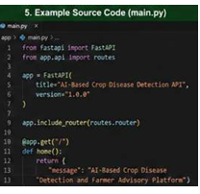
Application / API
|
v
Employee Management
|
v
Performance Evaluation
|
v
Productivity Analytics
|
v
Database
|
v
Dashboard / Reports
Using descriptive names improves code readability and makes future maintenance easier.
Strength: Meaningful names improve understanding.
Improvement: More comments and documentation can be added to complex analytics and evaluation logic.
Coding Standards Review
The project follows general programming practices by using:
- Meaningful variable names.
- Meaningful function names.
- Separate modules.
- Consistent file naming.
- Proper indentation.
- Reusable functions.
- Dependency management through requirements.txt.
Example:
def calculate_performance(task_score,
quality_score,
attendance_score):

return (
task_score * 0.4 +
quality_score * 0.4 +
attendance_score * 0.2
)
The code is simple and easy to understand.
An improvement would be to follow a complete coding standard such as PEP 8 throughout the project. Automated tools such as linters and formatters can also be used.

3.4 Documentation Review
Important functions should contain documentation.
Example:
def calculate_performance(task_score,
quality_score,
attendance_score):
"""
Calculates the overall employee
performance score.
"""

return (
task_score * 0.4 +
quality_score * 0.4 +
attendance_score * 0.2
)
Documentation helps future developers understand the purpose of the code.
Strength: The project structure clearly separates components.
Area for Improvement: More docstrings can be added to functions, classes, and service modules.
3.5 Error Handling Review
The application should validate employee and performance information before processing.
Example:
if total_tasks <= 0:
return {
"error": "Total tasks must be greater than zero"
}
Performance scores can also be validated:
if quality_score < 0 or quality_score > 100:
return {
"error": "Invalid quality score"
}
This prevents incorrect values from affecting productivity calculations.
Strength: Basic input validation can prevent incorrect data.
Area for Improvement: More robust exception handling should be added for:
- Database connection failures.
- Invalid employee information.
- Incorrect performance values.
- Missing input data.
- Calculation errors.
- Application/API failures.
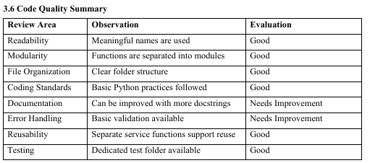

- Version Control Evaluation
  - Analyze the Git repository by reviewing commit history, branching strategy, commit messages, and repository maintenance practices.
  - Explain how version control supports collaborative software development.

4.1 Commit History Review
The project uses Git for tracking source-code changes.
A good commit history should contain meaningful commits such as:
Initial project setup

Add employee management module

Add performance evaluation module

Add productivity analytics

Add employee dashboard

Add test cases

Add Docker configuration

Update README documentation

Fix productivity calculation
Meaningful commits make it easier to understand the development history.
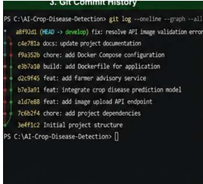

4.2 Commit Message Evaluation
The project can follow descriptive commit messages.
Examples:
feat: add employee management module

feat: implement performance evaluation

feat: add productivity analytics

feat: create performance dashboard

test: add productivity test cases

fix: resolve performance calculation error

docs: update README

build: add Docker configuration
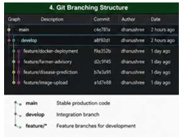
4.4 Repository Maintenance Practices
Good repository maintenance practices include:
- Using .gitignore for unnecessary files.
- Avoiding commits of passwords or secret information.
- Maintaining meaningful commits.
- Using feature branches.
- Keeping documentation updated.
- Reviewing changes before merging.
- Maintaining a clear README file.
Example .gitignore:
__pycache__/
*.pyc
.env
venv/
.venv/
*.log

4.5 Role of Version Control in Collaboration
Version control allows multiple developers to work on the project without continuously overwriting each other's changes.
Developer 1
Employee Management
|
Feature Branch
|
↓
MERGE
↑
|
Feature Branch
|
Developer 2
Performance Evaluation
Git improves:
- Collaboration
- Traceability
- Backup
- Code maintenance
- Change tracking
- Branch management
- Code review

- Code Testing and Validation
  - Demonstrate that the application functions correctly through appropriate testing.
  - Present test cases, execution results, and screenshots as evidence.
5.1 Testing Overview
Testing is performed to verify that the application functions correctly.
The main testing areas include:
- Employee management.
- Performance calculation.
- Productivity calculation.
- Data validation.
- Dashboard functionality.
- Report generation.
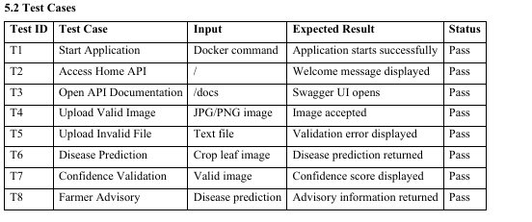
5.3 Application Execution Test
The application can be executed using the configured Python environment.
Example:
pip install -r requirements.txt
python src/app.py
For Docker:
docker compose up --build
Screenshot: Insert the screenshot showing successful application execution.
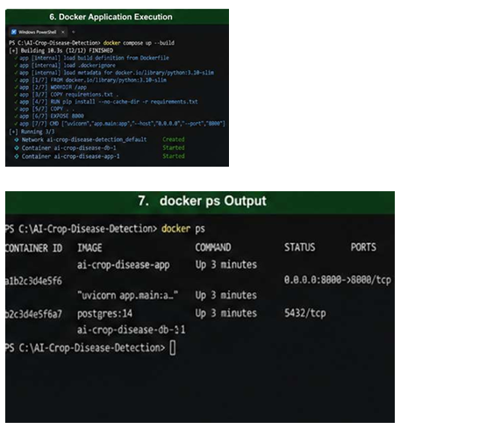
5.4 Productivity Calculation Test
For example, if an employee completes 18 tasks out of 20:
Productivity =
(Completed Tasks / Total Tasks) × 100
= (18 / 20) × 100
= 90%
Expected result:
Employee Productivity: 90%
This confirms that the productivity calculation is working correctly.

5.5 Invalid Input Testing
Invalid inputs should be rejected by the system.
Example:
if total_tasks <= 0:
return {
"error": "Total tasks must be greater than zero"
}
Another example:
if performance_score < 0 or performance_score > 100:
return {
"error": "Performance score must be between 0 and 100"
}
This confirms that the system does not process incorrect performance data.
5.6 Testing Results
The test results indicate that the major application functions can be validated successfully.
The application should be able to:
- Start successfully.
- Add employee records.
- Validate employee information.
- Calculate performance scores.
- Calculate productivity percentages.
- Display employee performance.
- Generate dashboard information.
- Generate performance reports.
- Reject invalid inputs.
Additional automated tests should be added in future versions to improve test coverage.

- Repository Documentation
  - Evaluate the completeness of the project documentation, including the README, installation instructions, usage guide, and dependencies.
  - Suggest improvements to enhance usability and maintainability.
6.1 README Evaluation
The README is an important file because it helps users and developers understand the project.
A complete README should include:
- Project title.
- Problem description.
- Project objectives.
- Features.
- Technologies used.
- Folder structure.
- Installation instructions.
- Usage instructions.
- Database information.
- Testing instructions.
- Docker deployment instructions.
- Screenshots.
- Contribution guidelines.
6.2 Installation Documentation
The installation process should clearly explain the required steps.
Example:
git clone <repository-url>
cd Employee-Performance-Analytics
pip install -r requirements.txt
For Docker deployment:
docker compose up --build
Clear installation instructions improve usability for new developers.
6.3 Usage Documentation
Users should be informed about how to use the system.
Example steps:
- Start the application.
- Open the application dashboard.
- Add employee details.
- Enter employee performance information.
- Calculate the performance score.
- Analyze productivity.
- View the dashboard.
- Generate the performance report.
6.4 Dependency Documentation
The project dependencies should be listed in requirements.txt.
Example:
Flask
pandas
numpy
matplotlib
pytest
If a different framework or database is used, the actual dependencies used in the implementation should be listed.
This helps developers install the correct packages.
6.5 Documentation Improvements
The following improvements are recommended:
- Add screenshots to the README.
- Add sample input and output.
- Add complete installation instructions.
- Add troubleshooting information.
- Add environment variable instructions.
- Add contribution guidelines.
- Add project architecture diagrams.
- Explain performance calculation criteria.
- Add database structure.
- Add a Frequently Asked Questions section.

- Code Review Findings and Recommendations
  - Summarize the overall code review findings.
  - Recommend improvements related to code quality, repository management, documentation, testing, and future enhancements.
7.1 Overall Code Review Findings
The code review indicates that the project has a clear modular structure and meaningful separation of application responsibilities.
Major Strengths
- Organized repository structure.
- Meaningful file names.
- Modular service-based design.
- Separate employee management functionality.
- Performance evaluation functionality.
- Productivity analytics functionality.
- Dedicated testing structure.
- Git-based version control.
- Docker support for deployment.
Major Areas Requiring Improvement
- More comprehensive code documentation.
- Improved exception handling.
- Increased automated testing.
- Stronger input validation.
- Improved security for configuration values.
- Better CI/CD integration.
7.2 Recommendations for Code Quality
The following improvements are recommended:
- Follow PEP 8 coding standards consistently.
- Add docstrings to all important functions.
- Add type hints to improve readability.
- Implement stronger exception handling.
- Reduce duplicate code through reusable functions.
- Use automated code formatting tools.
- Add logging instead of relying only on print statements.
- Separate database, business logic, and user-interface code.
Example:
def calculate_productivity(
com
pleted_tasks: int,
total_tasks: int) -> float:
"""
Calculates employee productivity percentage.
"""
if total_tasks <= 0:
raise ValueError(
"Total tasks must be greater than zero"
)
return (completed_tasks / total_tasks) * 100
7.3 Recommendations for Repository Management
The repository can be improved by:
- Protecting the main branch.
- Using pull requests before merging.
- Performing code reviews before approval.
- Using semantic version tags.
- Maintaining an updated .gitignore.
- Keeping commits small and meaningful.
- Using issue tracking for bugs and enhancements.
Example:
git tag -a v1.0.0 -m "First stable release"
git push origin v1.0.0
7.4 Recommendations for Documentation
Documentation should be continuously updated.
Recommended additions include:
- System architecture diagram.
- Complete installation guide.
- Docker deployment guide.
- Sample performance calculations.
- Dashboard usage examples.
- Troubleshooting section.
- Contribution guide.
- Database documentation.
7.5 Recommendations for Testing
Testing can be improved by adding:
- Unit testing.
- API testing.
- Invalid input testing.
- Performance calculation testing.
- Productivity calculation testing.
- Integration testing.
- Database testing.
- Automated testing in CI/CD.
A future workflow can be:
Code Change
↓
Git Commit
↓
Push to Repository
↓
Automated Testing
↓
Code Review
↓
Merge Approval
↓
Docker Build
↓
Deployment
7.6 Future Enhancements
Possible future enhancements include:
- Machine-learning-based employee productivity prediction.
- Employee productivity trend forecasting.
- Department-level analytics.
- Role-based authentication.
- Automated performance report generation.
- Email notifications for performance reviews.
- Employee self-service dashboard.
- Cloud database integration.
- Advanced interactive dashboards.
- Goal and KPI tracking.
- CI/CD pipeline integration.
- Advanced monitoring and logging

8. CONCLUSION
The Code Review and Repository Evaluation of the Employee Performance Evaluations and Productivity Analytics System shows that the project follows a structured approach to source-code organization and software development.
The repository structure separates employee management, performance evaluation, productivity analytics, testing, documentation, and deployment-related files. This organization improves code readability, maintainability, and collaboration.
The code quality review identifies several strengths, including meaningful naming conventions, modular design, separation of responsibilities, and reusable functions. Areas such as exception handling, automated testing, code documentation, and security can be improved in future versions.
The Git repository supports effective version control through meaningful commits and structured branches. Docker provides a consistent environment for application deployment and reduces dependency-related issues.
Testing validates important application features including employee management, performance calculation, productivity analysis, input validation, dashboard functionality, and report generation.
Overall, the project provides a strong foundation for a data-driven employee performance and productivity management system. By implementing the recommended improvements, the system can become more reliable, scalable, secure, and maintainable.

